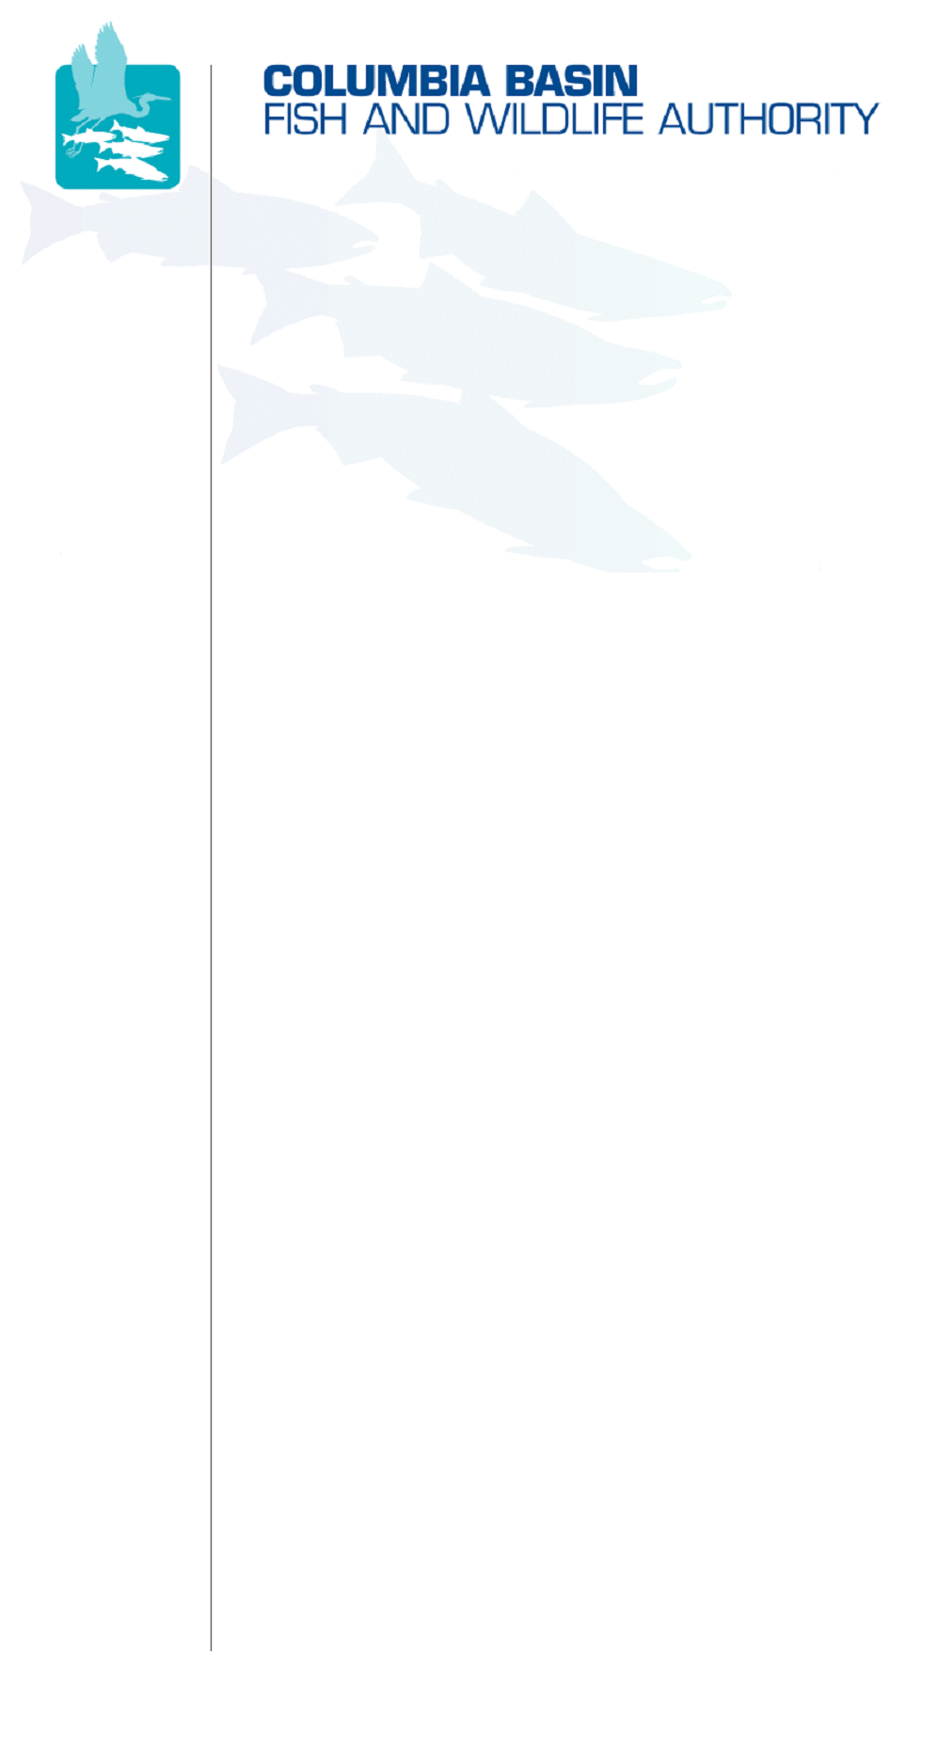
851 SW Sixth Avenue, Suite 300 | Pacific First Building | Portland, OR 97204-1339 |
Phone: 503-229-0191 | Fax: 503-229-0443 | www.cbfwa.org

March 31, 2008

TO:  Coordinating and promoting effective protection and  restoration of fish, wildlife, and their  habitat in the  Columbia River Basin.  The Authority is comprised of the following tribes  and fish and wildlife agencies:  Burns Paiute Tribe  Coeur d’Alene Tribe  Confederated Salish and Kootenai Tribes  of the Flathead Reservation  Confederated Tribes  of the Colville Reservation  Confederated Tribes  of the Umatilla Indian Reservation  Confederated Tribes  of the Warm Springs Reservation  Confederated Tribes and Bands of the Yakama Nation  Idaho Department  of Fish and Game  Kootenai Tribe  of Idaho  Montana Department  of Fish, Wildlife and Parks  National Marine Fisheries Service  Nez Perce Tribe  Oregon Department  of Fish and Wildlife  Shoshone-Bannock Tribes of Fort Hall  Shoshone-Paiute Tribes of Duck Valley  U.S. Fish & Wildlife Service  Washington Department of Fish  and Wildlife  Coordinating Agencies  Columbia River  Inter-Tribal Fish Commission  Upper Columbia  United Tribes  Compact of the Upper Snake River Tribes | Members
FROM: | CBFWA Staff
SUBJECT: | Proposed Modifications to CBFWA Amendment Recommendations by NOAA Fisheries

At the March 28, 2008 Members conference call, Rob Walton, NOAA Fisheries, informed the Members that his organization would be providing a list of modifications/suggestions for editing the CBFWA amendment recommendations for your consideration. Rob provided the list of recommendations to CBFWA staff and we have prepared the attached summary with our recommendations on how to resolve them. Out of the 11 comments, CBFWA staff determined that seven were editorial in nature and not substantive, whereas, four comments would have to be resolved through Member action.

Please provide comment to CBFWA staff if you disagree with our analysis. We will be discussing the four substantive issues at the April 2 Members conference call.

If you have questions or concerns, please contact Tom Iverson or Brian Lipscomb.

/tmp/in/input.doc

NOAA Fisheries suggestions for CBFWA 3/31/08

Issue | Question | Requested Change | CBFWA Staff Suggested Response
Cover Letter | Have we clarified that the appendix is not approved by members and is not a recommendation? |  | Yes.
Disclaimer on Appendix |  | THE DOCUMENTS IN THE APPENDICES WERE DISCUSSED BY CBFWA MEMBERS IN THE DEVELOPMENT OF CBFWA’S RECOMMENDATIONS BUT ARE NOT A PART OF THE CBFWA CONSENSUS RECOMMENDATIONS AND DO NOT NECESSARILY REFLECT THE VIEWS OF THE AGENCIES’ AND TRIBES’ TECHNICAL, POLICY, OR LEGAL STAFF. | Yes.  Including disclaimer on cover of Appendix.
1.4 | Reference to gaps and steps is ambiguous. | Clarify:  Insert: “Fish and Wildlife Program” in bullet #2 after “between” and before “objectives”  Bullets 4,6,7 and 8 refer to steps, presumably (but not clearly) referring to figure 2.1.5.1, which applies only to listed salmonids. Therefore, delete reference to steps in this section. | Yes.  Accept suggested edit.  Replace “elements” in lead in sentence to “steps”. Removes ambiguity.
2.1.2 | SARs | Change to read: “As a long-term goal, contribute to achieving…” | Member Decision: The Fish and Wildlife Program currently states “As an interim objective, contribute to achieving…” To change the SARs from an interim objective to “a long term goal” is a substantive change in meaning and needs to be discussed among the Members.
2.1.4 |  | In Table 2.1.4, delete the strategies in each of the three rows and insert one strategy: “ Manage to increase juvenile survival and adult returns.”  2.1.4.1 delete “Provide migration velocity” and insert: “provide flows to enhance migration conditions.  In the fourth bullet, delete “bypass passage” and insert “improve bypass survival.” | Member Decision: See Alternative Table 2.1.4 Below  Specific members requested that the word “flow” be removed, and “velocity” inserted.  ”Improved bypass survival” has a different meaning than “reduce bypass passage”. This would require member discussion.
2.1.5 | Needs to be more consistent with BiOp | In the first sentence in 2.1.5 Monitoring, after “is based in part on” add: “the RM&E measures in the FCRPS BiOp and…” | Yes.  Editorial comment.
2.1.5.3 |  | 2.1.5.3 Level 2 PIT Tag needs  Change to read: “PIT tagging levels should be determined, through regional RM&E discussions, and implemented to enable adequate monitoring of status and trends and estimates of overall FCRPS effects [Table 2.1.5.3.1 indicates an initial estimate supported by several, but not necessarily all, CBFWA parties.]” | Member Decision: Need to pass this language through the RM&E workgroup that crafted the final RM&E language.
2.1.5.5 | Life cycle monitoring | Add new language to the first sentence: “consistent with the FCRPS BiOp, Bonneville will fund…” | Member Decision: In the development of the RM&E provisions, we removed references to the FCRPS BiOp due to differing legal positions of our Members. The current language should be consistent with the BiOp without limiting additional effort for non-listed species.
2.1.5.7 | Regional mark processing center | Is it appropriate to direct BPA to fund the entire center? | Yes.  Insert “BPA funded hatchery portion of the” in the first sentence between “maintain the” and “coded wire tag database”.  Modify the final sentence to read “Specific activities related to the BPA funded hatchery portion of the RMPC include:”
2.1.5.9 | Harvest management | Add new language: “Consistent with the scope of this Program, improve estimates…” | Yes.  Editorial comment, consistent with recommendations.
3.1.3.1 |  | 3.1.3.1 [suggest new title] "Operate the FCRPS to more closely approximate the shape of the natural hydrograph and to enhance flows and water quality to improve juvenile and adult fish survival." | Yes.  Editorial comment, clarifying intent.

Alternate TABLE 2.1.4-
Table 2.1.4. Hydrosystem-related strategies and measures.
Strategy | General Measure | Limiting Factors
2.1.4.1:  Manage to increase juvenile survival and adult returns | 2.1.4.1a  Provide velocities to enhance migration conditions  2.1.4.1b  Provide spill  2.1.4.1c  Provide and evaluate surface bypass  2.1.4.1d  Reduce turbine and bypass passage  2.1.4.1e  Implement “spread the risk” transportation | - Increased travel time  - Direct mortality  - Delayed mortality; Latent mortality

/tmp/in/input.doc

